Kaohsiung Municipal Cianjin Junior High School  
ver.2025.May

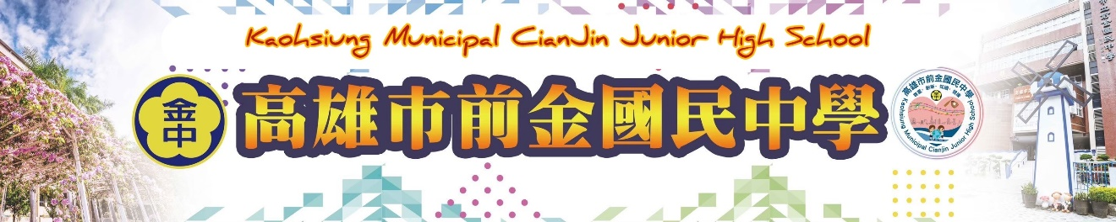

Brief Introduction of School History

This school was established in March 1946, in the name of “Kaohsiung Municipal Second Junior High School” as a boys’ school. We borrowed the premises of San Min Primary School as our temporary school buildings. In 1947, the Third Junior High School was merged into our school, and Mr. Chun-chi Chung held the position of Principal. At first, we borrowed the warehouses as our temporary schoolhouses from His Chia Army. In Autumn of the same year, the temporary schoolhouses were recovered by the army, so we turned to borrow classrooms from Chien Chin Primary School.

In February 1948, Mr. Chuang resigned his position at the school, and Mr. Show-Pan Lin was appointed to be the principal. In November 1950, the construction of new school buildings was completed, and we moved to the current address in February of the next year.

In August 1952, the school was approved to establish a high school and set up a Hsi Chia Branch on an experimental basis. In October 1954, the Senior High School Department was established formally, and the school name was changed to “Kaohsiung Municipal Second Middle School.”

In order to implement the “System of Promoting to a Higher School without Test” in Kaohsiung City, the number of classes at our school increased to 40 in September 1957. Based on the principle of “senior high schools to be managed by the province and junior high schools to be managed by the county/city,” we stopped the recruitment of senior high school students starting from the Academic Year 1962, and all senior high school students of our school were transferred to a provincial senior high school.

In September 1968, the name of the school changed to “Kaohsiung Municipal Chien Chin Junior High School” at the same time the Government implemented the 9-year national compulsory education, and we started to recruit both boys and girls.

In February 1970, Principal Lin retired and Mr. Shun-Hsiung Hsu, the Prefect of Studies, acted as the deputy principal temporarily. In April of the same year, Mr. Chien-Shun Tseng, principal of Tsoying Junior High School, was assigned to take over this school. In August 1975, Principal Tseng was transferred to Shou Shan Junior High School and Principal Neng-Hsiung Lin of Yen Cheng Junior High School was appointed to be the principal of this school.

In July 1978, Principal Lin retired and Mr. Shan-Chang Lee, Principal of Feng Shan Junior High School, Kaohsiung County was appointed to take over Principal Lin’s work in August. In 1983, the reconstruction of Ching Cheng Building was completed.

In February 1984, Principal Lee retired, and Mr. Chao-Mao Wang, Principal of Feng Lin Junior High School, Kaohsiung County, was assigned to take over the school. In February 1987, Principal Wang was transferred to Yen Cheng Junior High School, and Principal Shih-Yi Wang of Hsiao Kang Junior High School was appointed to take over this school.

In September 1990, Dr. Sun Yat-Sen Building was dismantled for reconstruction. In Academic Year 1989, the school established an Elite Class for the recruitment of talented students from all over the city. In 1990, the first PU running track in Kaohsiung was paved in the playground of this school. In 1991, the reconstruction of Dr. Sun Yat-Sen Building was completed and opened for use.

In August 1991, Principal Wu-Yi Wang was transferred to Ling Ya Junior High School, and the Director of Counseling Shu-Chen Chen of Kuang Hua Junior High School was assigned to take over his work. In Academic Year 1991, we established Music Class (Chinese Music), Cosmetics Class, Hairdressing Class and Skills Training Class.

The Principal’s dormitory was dismantled in October 1992 and reconstructed to be a parking lot. The school started to establish “Skills Training Classes” (Cooking Class, Hairdressing Class and Cosmetics Class) for moderately and seriously mentally retarded students in the 10th grade starting from the Academic Year 1994. In November 1994, we established the “Kaohsiung Juvenile and Youth Chinese Music Orchestra.”

In August 1997, Principal Shu-Cheng Chen was transferred to Yu Chang Junior High School and Principal Kuang-Ho Chung of Yu Chang Junior High School was assigned to take over the position of principal. Principal Kuang-Ho Chung retired in August 2000 and Secretary Wen-Chang Chou of Jui Hsiang Senior High School was transferred to this school to take over the position of principal. Principal Wen-Chang Chou was transferred to Kuo-chang Junior High School in August 2004 and Director of Counseling Kang Sen-Ping of Tsoying Junior High School was transferred to this school to take over the position of principal.

In August 2011, Principal Kang Sen-Ping retired and Ms. Tsai Yueh-Mei was promoted from Director of Yuan Fu Junior High School to take over the position of Principal at this school.

In August 2020, Principal Tsai moved to QiaoTou Junior High School as Principal. At the same time, Ms. Huang Wei-Ya (黃微雅)came from Zhongxia Junior High School to become this school's Principal till now.

Current Situation

Year by year, this school’s environment has been improved significantly and the teaching facilities were added and updated sufficiently to meet the education goals, such as the E-Learning Education Center, natural science classroom, basketball hall, library, auditorium, and modern classrooms, etc. So far, there are 19 classes (including Music Classes, PE Classes, Special Education Classes and Resource Class), 323 students and 71 teaching and administrative staff members in this school. There are 2.3725 hectares for the school campus.

School Motto

“ Honesty, Faithfulness, Diligence and Prudence.”

School Vision

Politeness and Law Abidance

Respect and Care

Healthiness and Vivacity

Variety and Innovation

School Philosophy

Happily learning – to help each student experience at least one successful event at school;

Professional Support – to have teachers with independent and multi-specialties to promote maximal teaching effectiveness;

Actively caring for the disadvantaged – to provide good opportunities for each student with a disability; A warm and friendly campus – to create humanistic care and multidisciplinary environments;

Having education partners – to coordinate community learning resources to have parents become educational partners.